American Data Group Inc.
Utility Billing
Period End Balancing Procedures

The procedures in this document are designed to help you balance ADG's Utility Billing System (UBS) with your financial application. Within this document, program menu access is based on the default menu structure. If you have a custom menu, then the menu selections will differ. You may use this document as a template for there may be unique processes required by your organization.
The period end balancing procedures may be run at anytime. At a minimum, ADG recommends you balance the UBS and financial system monthly. For your benefit, ADG prefers weekly balancing. If your systems become out-of-balance, their will be less data to review to determine when and why. The procedures should be follwed on the last day of the period, or the first day of the next period (where the period may be a day, a week, or a month). In any case, you must be aware that all information associated with the period be updated in both the UBS and financial applications.

UBS Closing Procedures:
When closing the period for the utility system – DO NOT UPDATE ANY TRANSACTION WITH A DATE GREATER THAN THE LAST DAY OF THE PERIOD YOU NEED TO BALANCE. THE MINUMUM DATE TO BALANCE WILL ALWAYS BE YESTERDAY (or the last working day). These procedures must be performed at the end of the the last day of the period or first thing on the 1st day of the new period.

- Update UBS Payments:
Post any payments normally done in UBS through the last day of the the period. This will included EFT-Bank Drafts, Credit Cards, or normal payments posted through the Cash Receipts Menu (ub300-me). Menu option #1 – Receipts Posting (ub311-pg) to post any receipts and option #2 – Receipts Edit/Update (ub312-pg) to edit and update the receipts to the customers account.
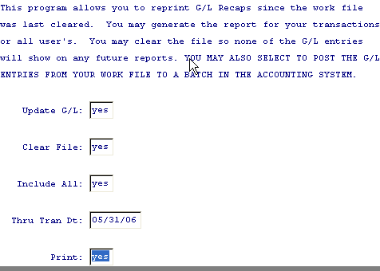
- G/L Interface:
On the Reports Menu, run option #4 – G/L Interface/Summary. This program will create journal entries needed to balance the UBS system with the financial system. These journal entries will have been created from billings, penalties, or payment processing procedures.

Update G/L: Yes - to create the interface to ADG's FMS application (ub296-ls)
Clear File: Yes – to delete the data interfaced (prevents duplicated postings)
Include All: Yes – includes journal entries from all users
Through Date: Period-Ending-Date – last day of period to balance
A report is generated listing journal entries created. These entries must be updated by your financial system to affect the G/L account balances and history..
- Aged Trial Balance Report:
From the Reports Menu, run option #1, Aged Trail Balance Report (ub645-ls). Report
parameters are:
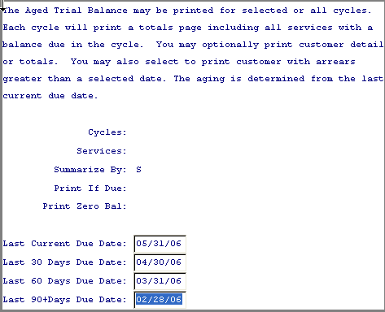
- Cycles: - Blank for all cycles
- Services: - Blank for all services
- Summarize By: - S, summarized by cycle
- Print If Due: - System automatically skips
- Print Zero Bal: - System automatically skips
- Due Dates: - enter current, 30, 60, 90+ days as desired. The dates do not matter for balancing procedures.
The last page of the report will resemble the following:
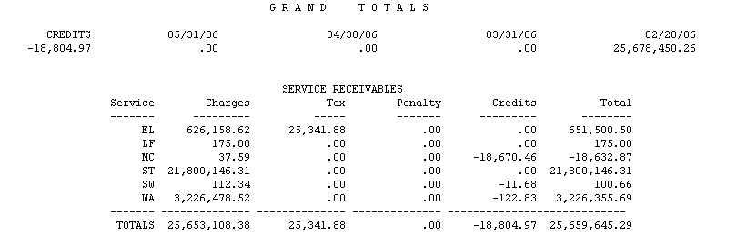
- Balance Deposits: (Optional – Only if you have customer deposits on file)
From the Pre-Billing Menu, run option #10, Deposit Status Report.
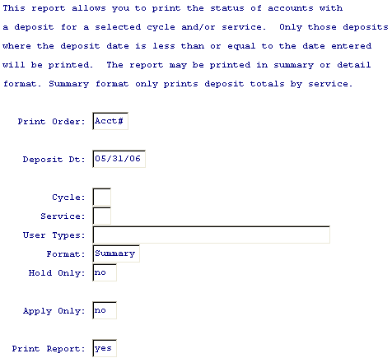
Print Order: - Acct#
Deposit Dt: - Last day of the month
Cycle: - blank for all
Service: – blank for all
User Types: – blank for all
Format: - blank for all
Hold Only: - no
Apply Only: - no
Print Report: - yes
The report output will resemble the following:
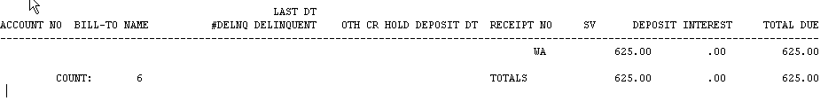

- A/R G/L Account Balances Report:
From the reports menu, run option #3, A/R G/L Account Balances Report (ub646-ls). The report will resemble the following.
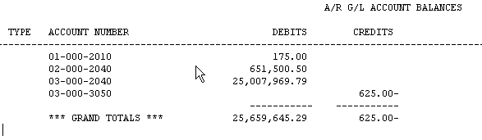
- Report Balancing:
In your UBS Available Services G/L setup, if the service liability account (customer credit balances) is the same as the service A/R account, then the 'Grand Total Debits' amount should balance to the Aged Trial Balance Totals/Totals value. In the above example, $25,659,645,29 is the same in both reports.
If you have a different liability account from the a/r account, then the total of 'Charges, Taxes, and Penalties' of the Aged Trial Balance should equal the 'Grand Total Debits'. The 'Grand Totals Credits' should equal the 'Total Credits' of the Aged Trial Balance plus total deposits).
The Deposit Status Report should balance to the A/R G/L Account Balances Report 'Total Credits' for each service. If multiple services share the same G/L deposit liability account, these services should be added together and compared to the associated G/L Account.
If either amounts DO NOT balance, it is due to corrupt data in your system. You must contact ADG support for assistance.

ADG FMS Closing Procedures:
** These procedures are NOT intended to reflect normal FMS monthly closings. **
- Update Batches:
Any batch associated with the utility billing system must be updated EVEN IF ITS FOR A DIFFERENT ACCOUNTING PERIOD. WHATEVER TRANSACIONS HAVE BEEN POSTED TO A CUSTOMER'S ACCOUNT BALANCE MUST ALSO BE UPDATED TO THE G/L.
To view un-updated batches, from the G/L File Maintenance Menu select option # 6, Batch Master. Any un-updated which include payments to utility customers, or journal entries created by the UBS G/L Interface must be UPDATED.
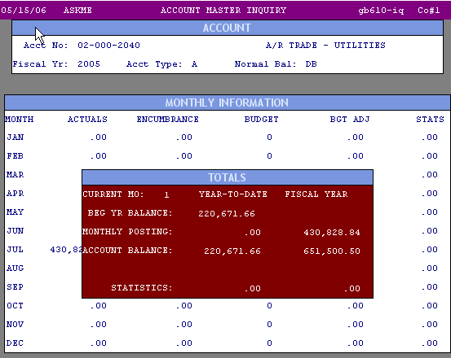
- To view each G/L Account Balance you may either perform an inquiry, or use the Advanced Financial Reports to create and print a report of the G/L Numbers listed on the A/R G/L Account Balances Report. The Fiscal-To-Date total for each G/L account should balance to the A/R G/L Account Balances Report.
The above account, 02-000-2040 for the fiscal year balances with theUBS A/R G/L Account Balances Report above.
The same applies for each Deposit Liability Account:
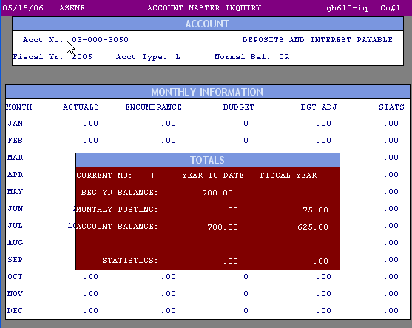

Accounts Don't Balance:
If any of the accounts on the A/R G/L Account Balances Report do not balance with the financial system, the most common problem is that all the batches (Cash Receipts or UBS Interfaces) have not been updated. The other is that you are trying to Balance Back to a date. This can not be done. You must always balance to the most recent date where transactions have been updated to the customer's account.
An optional report to option #15 from the Additional Reports Menu, 'A/R Balances As Of Date'. If the current date total is not same the total net A/R due from the A/R G/L Account Balances Report, some billing or payment records where posted with an invalid date (as in the example below).

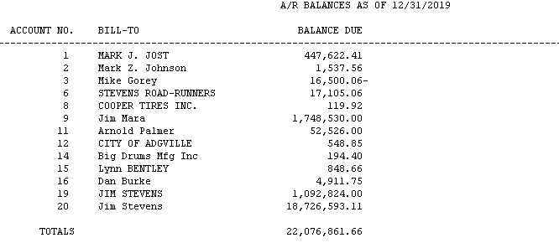
To correct this problem, you must contact support at ADG.
If the amounts still do not balance, check the batches that were posted to each A/R & Liability G/L account to verify no entries were posted to these accounts which did not also affect a customer's utility account balance.
If the deposit liability g/l accounts do not balance, as above, check the journal transaction history for entries which may not have also updated a customer's deposit balance. A common reason for deposits to not balance is because deposit file maintenance was done to a customer's deposit file not properly posted via cash receipts (incorrectly applied a deposit refund, finalled the wrong account, or mistaken applied a deposit to a customer's account balance).

